

**Faculty of engineering - Shoubra**

**Benha University**

**Research Article / Research Project / Literature Review**

in fulfillment of the requirements of

|  |  |  |
| --- | --- | --- |
| **Department** | |  | | --- | | **Engineering Mathematics and Physics** | |
| **Division** | |  | | --- | | **-----------** | |
| **Academic Year** | |  | | --- | | **2019-2020 Preparatory** | |
| **Course name** | |  | | --- | | **Computer** | |
| **Course code** | |  | | --- | | **ECE001** | |

**Title: -**

**Big data**

By:

|  |  |  |  |
| --- | --- | --- | --- |
|  | Name | Edu mail | B.N |
| 1 | حسن عارف علي النجار | hasan195329@feng.bu.edu.eg | 298 |

**Approved by:**

|  |  |
| --- | --- |
| Examiners committee | Signature |
| |  |  | | --- | --- | | 1 | Dr.Ahmed Bayoumi | |  |
| |  |  | | --- | --- | | 2 | Dr.Shady Elmashad | |  |
| |  |  | | --- | --- | | 3 | Dr. Abdelhamid Attaby | |  |
|  |  |
|  |  |

**Literature Review**

Big data is a The quantities, characters, or symbols on which operations are performed by a computer, which may be stored and transmitted in the form of electrical signals and recorded on magnetic, optical, or mechanical recording media Big Data is also **data** but with a **huge size**. Big Data is a term used to describe a collection of data that is huge in volume and yet growing exponentially with time. In short such data is so large and complex that none of the traditional data management tools are able to store it or process it efficiently.

Github link: <https://github.com/hassan-aref655/html-project-repository>

Github pages: <https://hassan-aref655.github.io/html-project-repository/>

**Screen shots for web site**

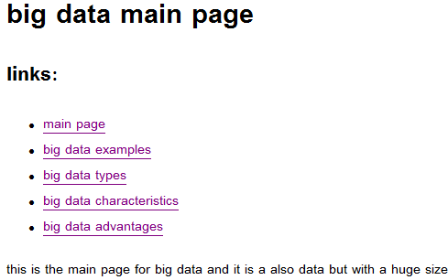

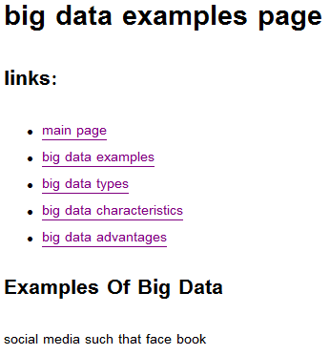

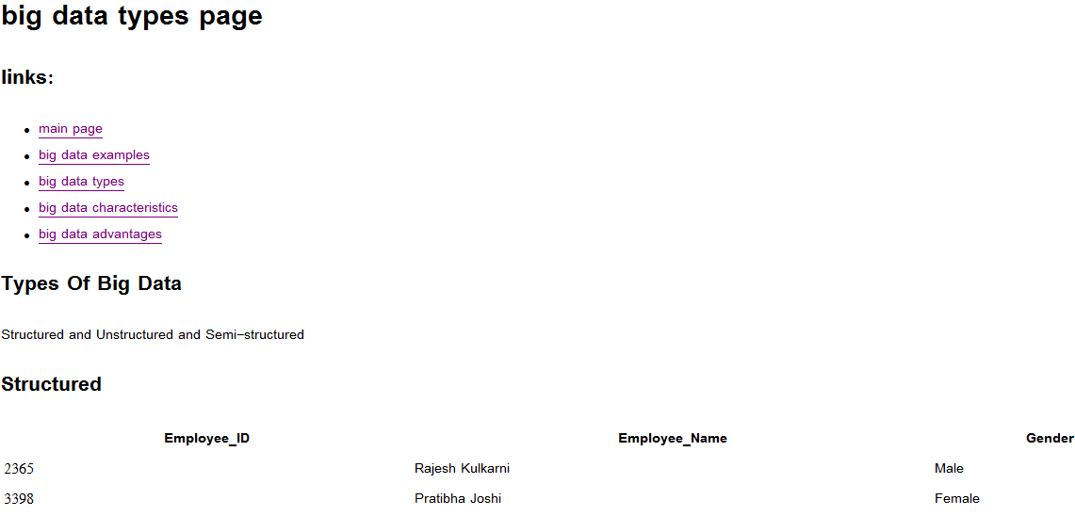

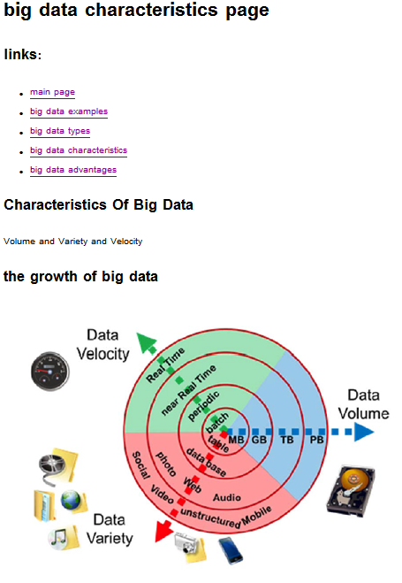

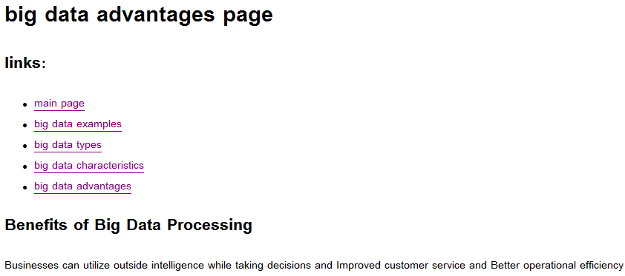

**Screen shots for source code**



